ProductConfigurator Admin View

Todo

* Resourcenames  
  Admin.Catalog.Manufacturers

Manufacturer

ProductConfigurator

# Controllers



# Factories



# Models

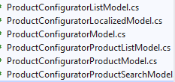

# Validators



# Views

# Other classes

Nop.Services.Security.StandardPermissionProvider

Nop.Services.ExportImport.IExportManager

Nop.Services.ExportImport.IImportManager